Smart Traffic Light Monitoring System Using Image Processing

Dr.M.Pandi | R.Samitha
Associate Professor,Computer Science and Engineering | Computer Science and Engineering
Dr.Mahalingam College of Engineering and Technology | Dr.Mahalingam College of Engineering and Technology
Pollachi,India | Pollachi,India
mpandi123@gmail.com | samitharameshrs@gmail.com
D.S.Tamilarasan | R.Nikesh
Computer Science and Engineering | Computer Science and Engineering
Dr.Mahalingam College of Engineering and Technology | Dr.Mahalingam College of Engineering and Technology
Pollachi,India | Pollachi,India
tamilarasan2k01@gmail.com | chiyaannikesh005@gmail.com

Abstract— The movement of cars through intersections where several roads converge is frequently tracked and managed by traffic signal control systems. But considering the different characteristics involved, coordinating numerous systems of traffic lights at nearby junctions is a difficult task. The main focus of traditional approaches is giving all lanes a comparable amount of time. Additionally, the current traffic system does not take into account the reciprocal interaction among nearby traffic light networks, the variation in car flows over time, collisions, the approaching of emergency vehicles, or crosswalks for pedestrians. Traffic congestion and delays result from this. Road traffic management has been utilised as a means of ensuring the security of both vehicles and pedestrians. Therefore, in order to minimise the amount of individual fatalities, it is crucial to begin developing an algorithm as rapidly as practicable. To identify and categorise Low, Medium, and Heavy Traffic in the movement of highway traffic in actual time, however, currently does not exist modern technology that is as reliable as it needs to be. In order to solve this issue, the study recommends using road images for refining a machine learning model for recognising traffic and categorization. From collections of actual road visual data, the Convolutional Neural Network (CNN) model has been instructed to recognise and classify traffic. The CNN approach, that is based on the design of Xception and employs the ADAM optimizer, is recommended for improved categorization. Each lane's traffic volume is categorised as low, medium, or high according to the CNN algorithm. The microcontroller chooses these levels depending on information from the CNN model. The Microcontroller assigns durations for the lanes and modifies the red, yellow, and green signals based on the volume of traffic. The possibility for employment in a fast and precise identification of traffic on the roadways is shown by the suggested method's efficiency, which outperforms the current version of research.

Keywords— traffic congestion, Intelligent traffic system, machine learning, deep learning, Neural networks
- INTRODUCTION
The overall amount of automobiles on the road has dramatically risen throughout the years. Everybody now has to deal with the growing issue of congested roads on a daily

basis [1]. The effectiveness of traffic-by-traffic police control by hand has not been established. Additionally, this issue has not been resolved by the signal's predetermined time limit
under all conditions (both low and high traffic density). Machine learning (ML), a branch of artificial intelligence (AI), is one of among the most important and popular fields that is currently evolving. Recently, the topic of machine learning has become an important and prospective one for research in the discipline of transportation engineering, notably in the area of traffic prediction. There needs to be some sort of modest forecast of traffic since congestion in the roadways affects individuals of all walks of life and makes it difficult for them to live their lives without tension or irritation. To ensure the nation's financial advancement, highway users' comfort comes before anything else[2]. This is only practical with a constant stream of traffic. In order to solve this problem, forecasting traffic is necessary in order to ensure we are able to approximate or anticipate potential traffic.
Government funding for the intelligent[3] transportation system (ITS) is also being used to deal with these issues. The primary objectives of this study are to categorise different methods for machine learning and hypothetically develop Python 3 models. The goal of stream of traffic forecasting is to provide users with an immediate assessment of traffic. So, traffic predictions could benefit from this research. The Internet of Things (IoT)[4] is presented as a solution to the aforementioned issues. In order to calculate and analyse the data, we employ machine learning. The results are then displayed using a Processing app and an IOT-based platform.
The development and implementation of an IOT-based traffic tracking and management device employing image processing is the goal of this work. By managing traffic signals, the system will make the way for vehicles. The system utilises an advanced idea for an IOT-based traffic control and surveillance platform. With the aid of a centralised system, we will use this technology to regulate each city path's traffic light. To control the system, an ESP32 microcontroller will be used in the control centre[5].
- The study suggests that road images be used to refine a machine learning model for traffic recognition and classification.
- The Convolutional Neural Network (CNN) model has been instructed to recognize and classify traffic using collections of actual road visual data. The CNN approach, that depends on the plan of Xception and utilizes the ADAM enhancer, is suggested for further developed arrangement.
- The CNN algorithm classifies the traffic volume in each lane as low, medium, or high. The microcontroller picks these levels relying upon data from the CNN model. Based on the volume of traffic, the Microcontroller modifies the red, yellow, and green signals and gives the lanes durations.
- The opportunities for work in a quick and exact distinguishing proof of traffic on the streets is shown by the recommended strategy's effectiveness, which beats the momentum rendition of examination.
The remainder of the essay is structured as a thorough literature review in the second section. In Part III, the choice of system tools and issue identifications are covered. In the fourth part, the system architecture and specific system design stages are covered. Potential improvement is used to wrap up the last part of the article.
- BACKGROUND STUDY
L. F. P. de Oliveira et al. (2021) By creating an administrative traffic light management system and employing a special wireless data system, the author developed a method that intends to improve signals for traffic. The most typical forms of urban junctions were examined to demonstrate the system's efficacy. In order to offer a comprehensive management system for exceptional occurrences, like stopping roads caused by crashes or public events, direct control procedures for network traffic lights were built. The traffic light system bulbs' functioning state was lastly reported to management at large using safety procedures.
S.S. Zia et al. (2019) One of the biggest issues in cities that are urbanising and populating more quickly is congestion in the roadways. Stress caused by air, noise, and fuel pollution therefore renders living in cities harder to live. Basic road signs operate using any of two straightforward processes: pavement loop sensors, which can detect when a motorist is in line for a green, or pre-established timing plans, which control the green-red sequence. These techniques are extremely basic for large centres like Karachi given the volume of traffic in all directions and the cyclical character of the oscillations. Similar to cell phones or other forms of technology, traffic lights too need to advance.
F.B.Poyen et al. (2016) A system is presented in which the length of the green and red light periods are determined by the volume of traffic that exists at that moment. Utilising PIR (proximity Infrared sensors) allows for this. The microcontroller (Arduino) is used to determine the green light's shining period after the density has been computed. The microcontroller will determine the amount of time an edge will remain available or whether to switch over the indicators after the sensors on the side of the road identify the existence of automobiles and communicate the data to it. We have outlined the steps involved in using this structure in the sections that follow.
A. M. H. Yusuf et al. (2020) Since the total number of cars grows in highly populated places, traffic signal management gets more crucial. With adaptable traffic lights, traffic signals can change the speed of traffic in accordance with the number of vehicles within every segment. The application of an agent-based simulation approach for managing signals was suggested in this study, with a particular emphasis on modelling using the Unity3D system and fuzzy logic control. Three different environments—busy, moderate, and smooth—were used for the purpose of assessment. The mean time spent waiting, typical amount of vehicle ceases, and mean speed of vehicles are part of the system's gauges of efficiency.
M. Sutharsan et al. (2020) It is suggested to use a vision-based reactive traffic light system. At a time when traffic was at its worst, the planned controller was effectively set up and evaluated as a whole system in a complicated crossroads in Colombo. The setup consisted of two primary components. A system that tracked traffic using vision made up the first component. In this section, a system was created that used cameras to record the lanes at a crossroads and analysed the captured video feeds to derive a traffic index that took into account factors including kind of vehicle, congestion level, and pixel-wise vehicle speeds.
Various existing papers are discussed in detail about the previous state of art approaches on traffic light detection system. The proposed approach derives the challenges and evaluate a model with reconfigurable design model[6]-[17].

III. SYSTEM DESIGN
In real time traffic monitoring deals with a number of challenges which are connected in a structure, anticipates traffic patterns at the appropriate resolution amounts (a person vehicles and platoons) for allowing assertive management, allows for different efficiency components to address the ordered sub issues, and employs a structure for information and computer/communication tackles which make it possible for a rapid resolution of the sub shortcomings in order to ensure all decisions must be produced using adequate time.
- The project's main objective is to utilise a model based on to analyse the pictures given to recognise traffic on roadways.
- In order to achieve this, records containing traffic picture data are employed to perfect the image categorization model.
- The post real-time highway images in order to categorise the amount of traffic as Low, Medium, Heavy, or No Traffic.
- The Microcontroller assigns a lane a light and modifies the red, yellow, and green indications according to the volume of traffic. The lane lights alter, corresponding on the designated photo.
- Automated monitoring and oversight technologies are designed to do away with the requirement for people to work in order to do routine vision-based activities that can be completed by a machine or a system that is computerised.
Computer vision technologies were additionally employed in a number of publicly accessible spaces, including highways, airports, and shopping malls. The duty of tracking and assessing traffic situations, with a focus on motorways and junctions, is a typical use of vision technologies. In order for real-time traffic management systems to be effective, a system like this must be able to identify changes in traffic characteristics in a timely manner. This will enable controllers and agencies to react to traffic conditions rapidly.
- METHODOLOGY
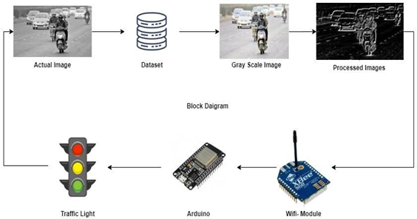

Fig. 1. System architecture of Proposed Traffic management system
By employing CNN, driving car photos were divided into four categories, including Low, Medium, High, and No Traffic, in this method. They show that when sophisticated CNNs are utilised for traffic category sorting, innovative outcomes can be produced. The most effective and strongest image processing technique at the moment, CNN uses a number of feature collection phases (hidden layers) which could dynamically acquire interpretations from the data being processed. Large amounts of data have sparked research into CNNs, and in the past few years, several highly intriguing deep CNN designs have been developed. Models of convolutional neural networks (CNNs) show strong adaptation to the testing sample and develop the ability to assign pictures as inputs to their identified categories. Experimental results on datasets from real life show that the proposed CNN method is effective for recognising traffic and can carry out the job with excellent accuracy on four objective traffic categories. The current condition of the traffic signals will be monitored by IOT.
Image acquisition
The current Traffic Images of information has been used to put the recommended ideas into practise. To design for the precise separation of traffic, this approach, involving multiple phases such as picture extraction, edge identification, and traffic identification and categorization, is employed.
Pre-processing
To give an ideal picture for processing, we perform some basic operations on photos in this section. In this module, we will perform a variety of operations to produce an acceptable fresh image, including gray scale transformation, sorting, grinding, softening, edge, and image division. The preprocessing step enhances the images' quality by reducing noise. Gray scale photographs, which are a subset of monochromatic black-and-white or grey photography, solely use the colour of grey. It is possible to evaluate the level of brightness of each pixel in grey scale images.

CNN for Image Classification
Separation of characteristics from an image is required for image categorization in order to spot some trends in the information being analysed. Due to the relatively huge variables that can be trained, using an ANN for picture categorization might end up becoming highly expensive when it comes to of processing.
For instance, if we wish to train our conventional ANN on a 50 x 50 image of a cat to determine whether it is a dog or a cat, the parameters we can train are -(50*50) * 100 image pixels multiplied by hidden layer + 100 bias + 2 * 100 output neurons + 2 bias = 2,50,30.
CNN architecture
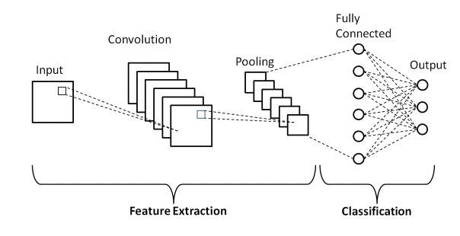

Fig 2. CNN architecture
Fig 2. Shows the Convolutional neural network (CNN) architecture. It consists of input layer, convolution layer, max pooling layer, fully connected layer and output layer.
CNN model with road photos and transfer learning for autonomous traffic identification. In transfer learning, weights from networks that have been trained on millions of data are used. The proposed study makes use of four distinct transfer learning models—ADAM, SGD, RMSprop—each with a distinct optimizer. Datasets that currently contain the most road photos were the subject of extensive experiments. This model uses three dense layers and the SoftMax layer for classification. Transfer learning is used to extract the features. In the deep TL models that have been suggested, quick learning is demonstrated using the Adam optimizer, and the dropout method stops the problem of overfitting. The system's performance can still be improved in future development by making use of larger datasets and other deep learning methods.
- RESULTS AND DISCUSSIONS

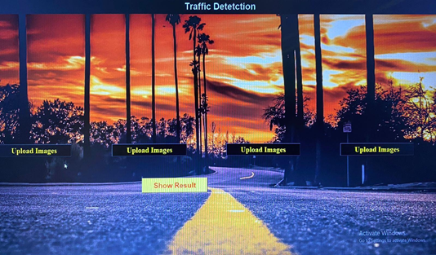
Fig 2. Traffic detection system – Front end design
Fig. 2. Shows the system front end design to upload the test images.
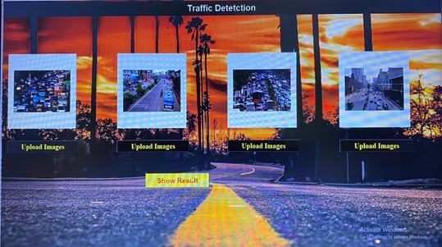
Fig 3. Image uploading
Fig 3. Shows the image upload process where multiple images from different cameras are uploaded.
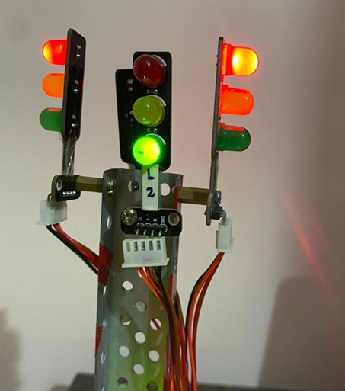
Fig 4. Traffic light set-up
Fig 4. Shows the traffic light set-up connected for 4-way lanes. The LED traffic light set up is integrated with microcontroller.
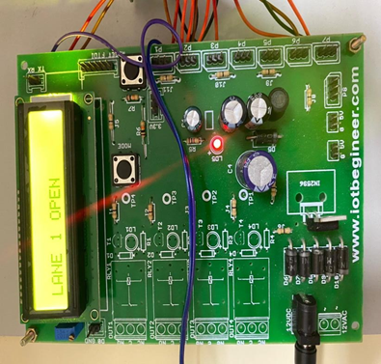
Fig 5. Integrated board
Fig 5. Shows the integrated microcontroller board connected with the traffic light set up.
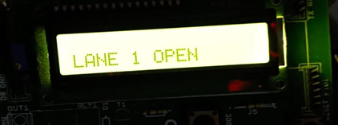
Fig 6. LANE 1 Open
Fig 6. The first image is lane1, second image represents the traffic in lane 2 and so on. Here, the images are preprocessed and classified in the backend using the Python libraries and models. The output is classified as no traffic, low, medium, and high traffic and sends the classified result to the microcontroller. According to the uploaded images, first the traffic light in the lane 1 changes, despite the density in other lanes. After the change in the signal in lane 1 the density is considered for the change of the signal in all other lanes

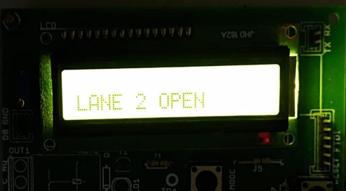
Fig 7. LANE 2 Open
Fig 7. Shows LANE 2 open for the given condition
Shows LANE 1 open condition occurs after the detection of traffic congestion. Figure Shows the change in signal from lane 1 to lane 2. The signal in lane 2 has low density and green signal stays for only few minutes. After lane 1, lane 2 opens, then lane 4 opens and finally lane 3 opens.

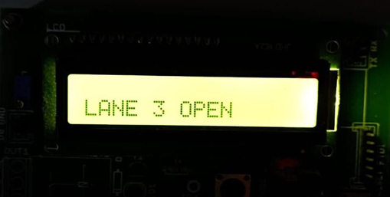
Fig 8. LANE 3 Open
Fig shows the lane 4, The density in lane 4 is low compared to lane 3, so lane 4 opens and the lights change according to the traffic and the timings. Fig 8 shows the change from lane 4 to lane 3. In the last lane 3 opens and the green signal lasts of more time as there is a huge traffic density.
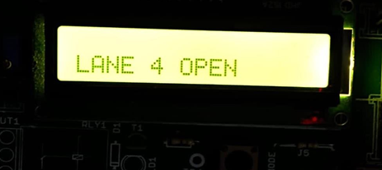
Fig 9. LANE 4 open
Fig 9. Shows the LANE 4 open up. As a result, it can be deduced from the preceding results that an approximate level of traffic that is comparable to real-time traffic values can be determined using image processing techniques and real-time images collected. Based on actual traffic densities, this information can be used to evaluate and control the traffic lights in real time. Time will be saved and traffic congestion will be lessened as a result of this.
- CONCLUSION
This causes traffic congestion and delays. Road traffic management has been used to make sure that pedestrians and vehicles are safe. As a result, developing an algorithm as soon as possible is essential to reducing the number of individual deaths. However, there is currently no modern technology that is as reliable as it should be to identify and classify Low, Medium, and Heavy Traffic in the movement of highway traffic in real time. The study suggests that road images be used to refine a machine learning model for traffic recognition and classification in order to address this issue. The Convolutional Neural Network (CNN) model has been instructed to recognize and classify traffic using collections of actual road visual data. The CNN approach, that depends on the plan of Xception and utilizes the ADAM enhancer, is suggested for further developed arrangement. The CNN algorithm classifies the traffic volume in each lane as low, medium, or high. The microcontroller picks these levels relying upon data from the CNN model. Based on the volume of traffic, the Microcontroller modifies the red, yellow, and green signals and gives the lanes durations. The opportunities for work in a quick and exact distinguishing proof of traffic on the streets is shown by the recommended strategy's effectiveness, which beats the momentum rendition of examination.
References
- L. F. P. de Oliveira, L. T. Manera and P. D. G. D. Luz, "Development of a Smart Traffic Light Control System With Real-Time Monitoring," in IEEE Internet of Things Journal, vol. 8, no. 5, pp. 3384-3393, 1 March1, 2021, doi: 10.1109/JIOT.2020.3022392.
- A. M. H. Yusuf and R. Yusuf, "Adaptive Traffic Light Controller Simulation for Traffic Management," 2020 6th International Conference on Interactive Digital Media (ICIDM), Bandung, Indonesia, 2020, pp. 1-5, doi: 10.1109/ICIDM51048.2020.9339649.
- M. Sutharsan, S. Rajakaruna, S. Y. Jayaweera, J. A. C. M. Jayaweera and S. Thayaparan, "Vision-Based Adaptive Traffic Light Controller for Single Intersection," 2020 5th International Conference on Information Technology Research (ICITR), Moratuwa, Sri Lanka, 2020, pp. 1-6, doi: 10.1109/ICITR51448.2020.9310872.
- Guo, K., Hu, Y., Qian, Z., Liu, H., Zhang, K., Sun, Y., & Yin, B. (2020). Optimized graph convolution recurrent neural network for traffic prediction. IEEE Transactions on Intelligent Transportation Systems, 22(2), 1138-1149.
- Xu, H., & Jiang, C. (2020). Deep belief network-based support vector regression method for traffic flow forecasting. Neural Computing and Applications, 32(7), 2027-2036.
- Zhao, F., Zeng, G. Q., & Lu, K. D. (2019). EnLSTM-WPEO: Short-term TFP by ensemble LSTM, NNCT weight integration, and population extremal optimization. IEEE Transactions on Vehicular Technology, 69(1), 101-113.
- Peng, H., Du, B., Liu, M., Liu, M., Ji, S., Wang, S., ... & He, L. (2021). Dynamic graph convolutional network for long-term TFP with reinforcement learning. Information Sciences, 578, (1) 401-416.
- B. Hussain, M. K. Afzal, S. Ahmad and A. M. Mostafa. (2021) . Intelligent TFP Using Optimized GRU Model. IEEE Access, 9(1), 100736-100746
- Ma, Q., Huang, G. H., & Ullah, S. (2020). A Multi-Parameter Chaotic Fusion Approach for Traffic Flow Forecasting. IEEE Access, 8(1), 222774-222781.
- Wang, Z., Su, X., & Ding, Z. (2020). Long-term traffic prediction based on lstm encoder- decoder architecture. IEEE Transactions on Intelligent Transportation Systems, 22(10), 6561- 6571.
- Kumar, B. R., Chikkakrishna, N. K., & Tallam, T. (2020). Short Term Predictions of Traffic Flow Characteristics using ML Techniques. In 2020 4th International Conference on Electronics, Communication and Aerospace Technology (ICECA) 4(1),1504-1508.
- Jia, T., & Yan, P. (2020). Predicting citywide road traffic flow using deep spatiotemporal neural networks. IEEE Transactions on Intelligent Transportation Systems, 22(5), 3101-3111.
- Qu, W., Li, J., Yang, L., Li, D., Liu, S., Zhao, Q., & Qi, Y. (2020). Short-term intersection Traffic flow forecasting. Sustainability, 12(19), 1-13.
- B. K. P. Horn and B. G. Schunck, HornSchunckOptical_Flow, vol. 17.
J. Redmon, S. Divvala, R. Girshick and A. Farhadi, You Only Look Once: Unified Real- Time Object Detection, 2015.
- S. Ren, K. He, R. Girshick and J. Sun, "Faster R-CNN: Towards Real-Time Object Detection with Region Proposal Networks", IEEE Trans. Pattern Anal. Mach. Intell., vol. 39, no. 6, pp. 1137-1149, 2017.
- V. Badrinarayanan, A. Kendall and R. Cipolla, "SegNet: A Deep Convolutional Encoder- Decoder Architecture for Image Segmentation", IEEE Trans. Pattern Anal. Mach. Intell., vol. 39, no. 12, pp. 2481-2495, 2017.
- Y. Zhou, L. Liu, L. Shao and M. Mellor, "DAVE: A unified framework for fast vehicle detection and annotation", Lect. Notes Comput. Sci. (including Subser. Lect. Notes Artif. Intell. Lect. Notes Bioinformatics), vol. 9906 LNCS, pp. 278-293, 2016

